**Positions for Patients in Bed used in Nursing**

**Learning outcomes**

1. Understand different methods to provide comfort to bedridden patients
2. Understand how to use supportive devices to provide comfort & safety to bedridden patients
3. Learn how to prevent bed sores for bedridden patients
4. Demonstrate difficult positions for physical examination of the patient

**Different Positions**

The most common positions used in nursing patients are:

1. Fowler’s position
2. Semi-Fowler’s position
3. Supine/Recumbent position
4. Prone position
5. Lateral/Side-lying position
6. Sims Position
7. Trendelenburg position

The other positions used for physical examination are:

1. Lithotomy position
2. Knee-chest (genu-pectoral) position
3. Reverse Trendelenburg position

**Different Positions**

**Fowler’s Position**

Patient’s head of bed is placed at a 45-degree angle. Hips may or may not be flexed. This is a common position to provide patient comfort and care.

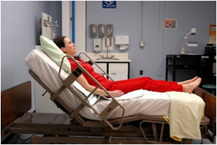 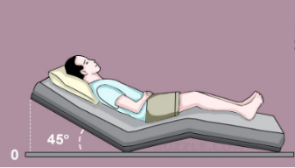

**Semi-Fowler’s Position**

Patient’s head of bed is placed at a 30-degree angle. This position is used for patients who have cardiac or respiratory conditions, and for patients with a nasogastric tube.

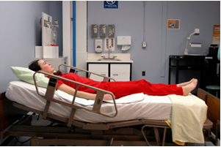 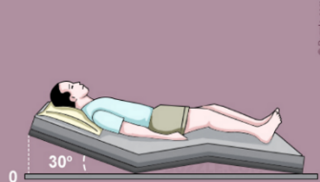

**Supine Position**

The supine position is assumed without a pillow after lumber puncture and also in spinal injuries. This position is also use when examining the anterior part of the body.

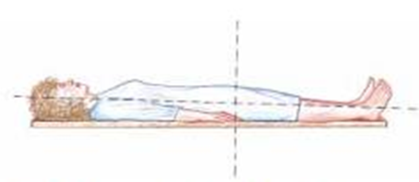 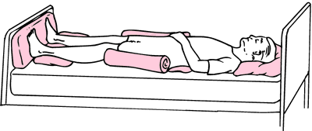

**Prone Position**

The Prone position is is a body position in which one lies flat with the chest down and the back up

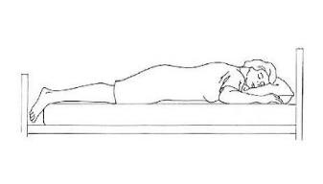 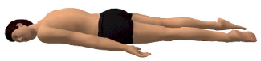

**Lateral Position**

Patient lies on his side with the upper leg flexed and the arms in front. It is used for comfort during rest and sleep.

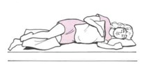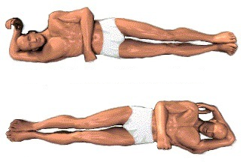

**Sims Position**

Patient lies between supine and prone with legs flexed in front of the patient. Arms should be comfortably placed beside the patient, not underneath

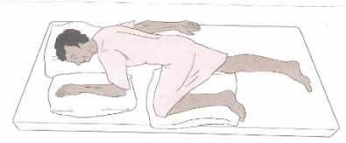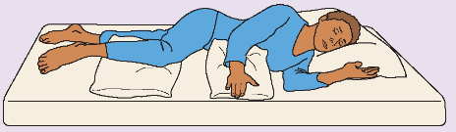

**Trendelenburg position**

Place the head of the bed lower than the feet. This position is used in situations such as hypotension and medical emergencies. It helps promote venous return to major organs such as the head and heart.

